1. Start page

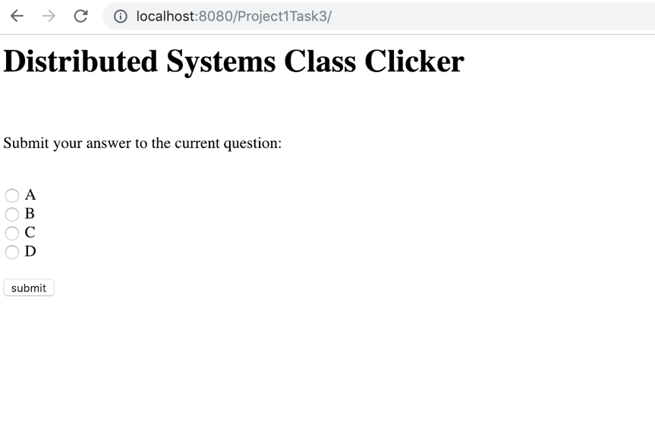

1. Input “A”, then it will show that the user has input “A”

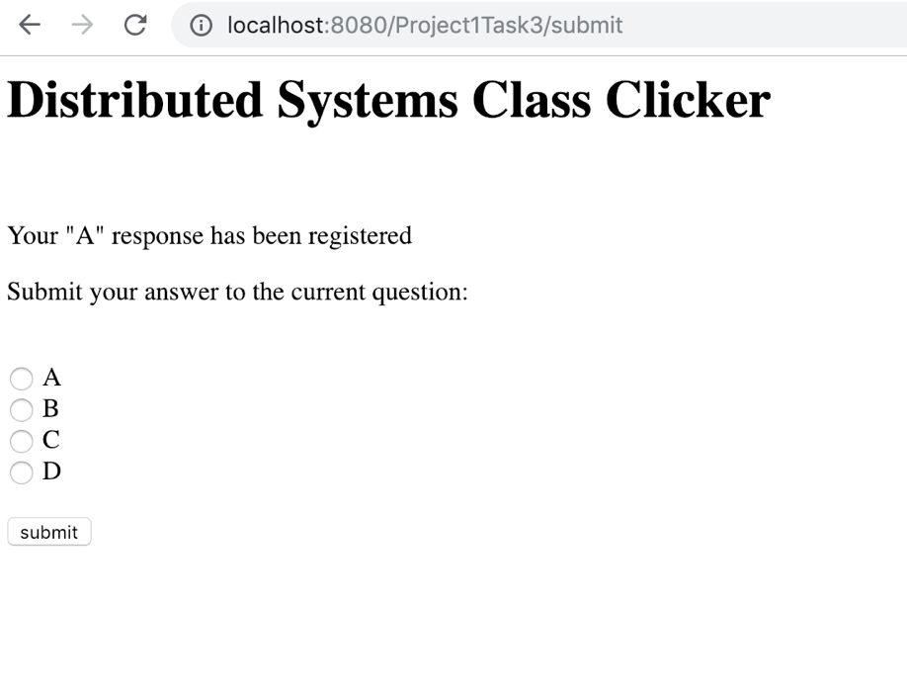

1. Type “/getResults” in the url and it will show the result page which give the user the number of each choice

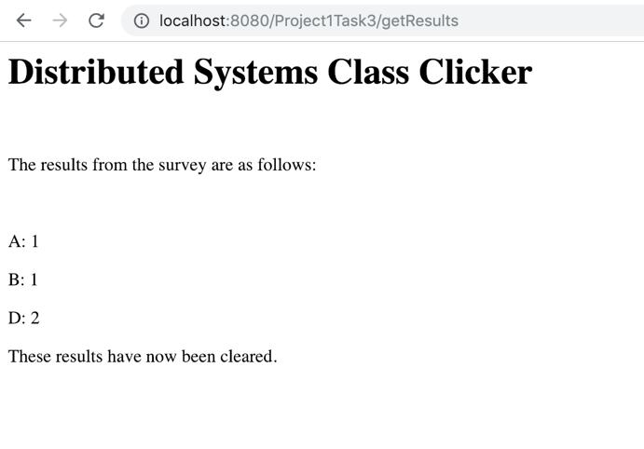

1. When input nothing, the page will show that “you input nothing”

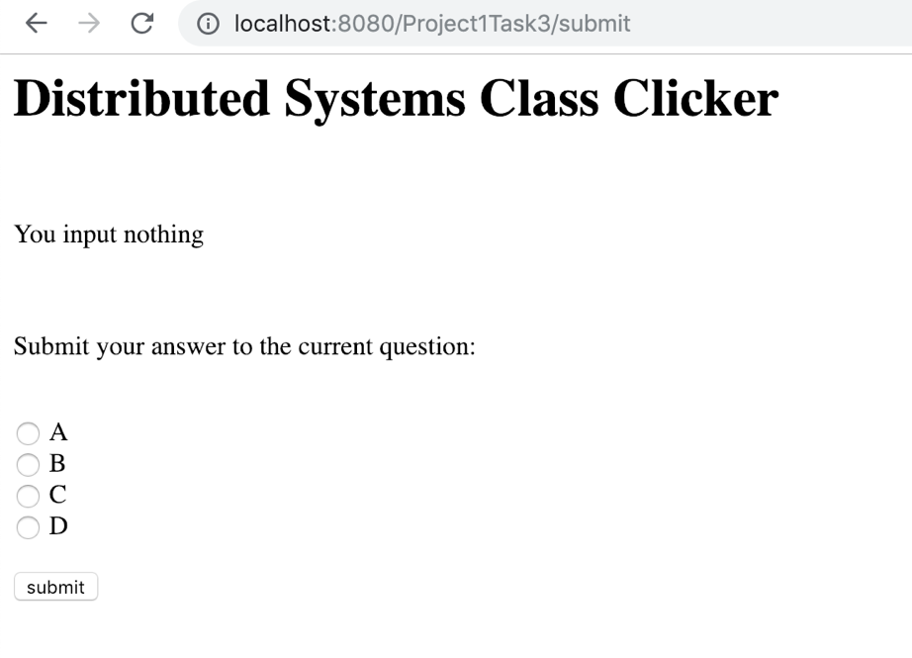

1. When there is no input, the results:

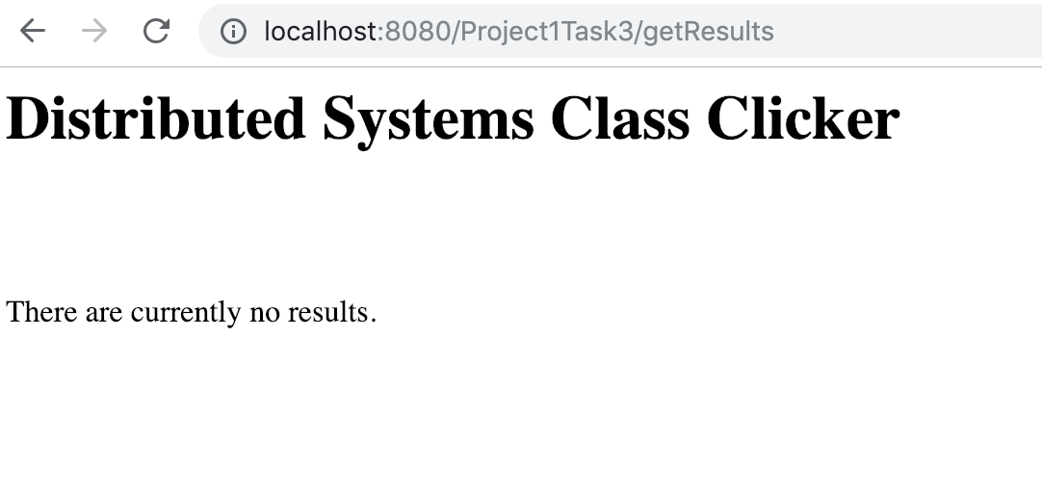

1. The mobile mode of the start page

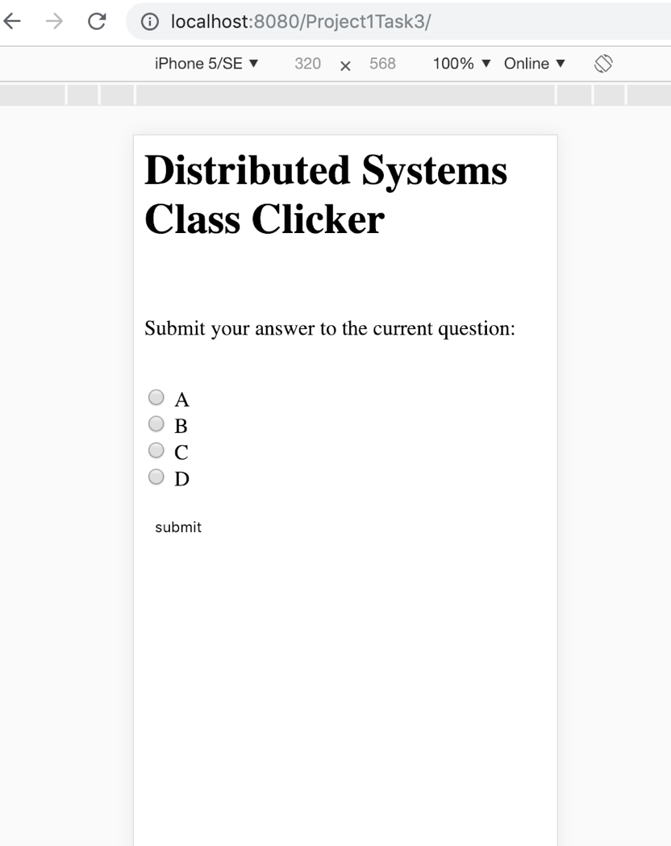

1. When input “A”, the screen in the mobile mode  
   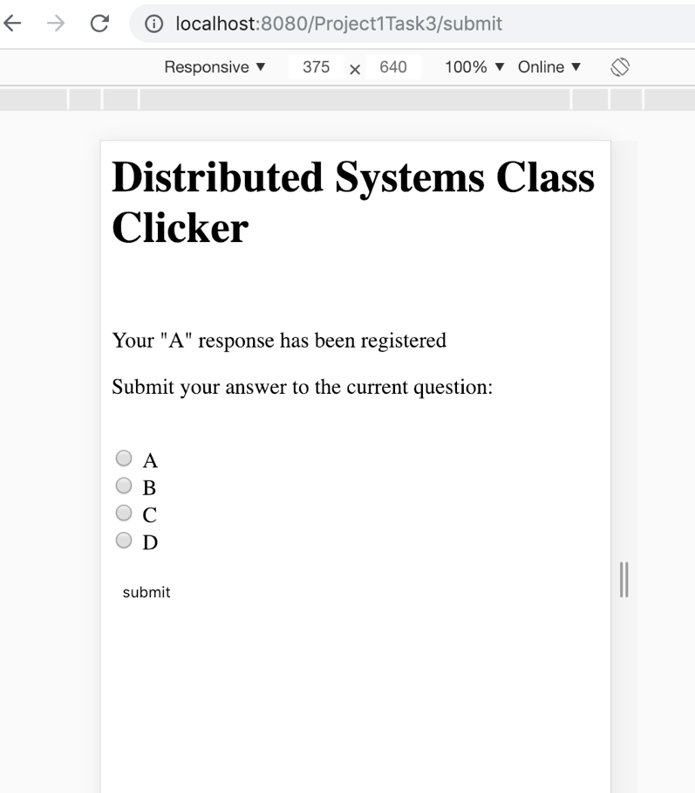
2. When we try to get result in the mobile mode, it will show:

